MSSQL Bank Loan Analysis
Bank Loan Report: Summary
KPI’s:
Loan Applications
1) Total Loan Applications
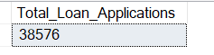
2) Month to Date (MTD) Loan Applications
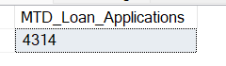
3) Previous Month to Date (PMTD) Loan Applications
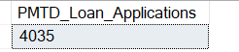
Funded Amount
4) Total Funded Amount
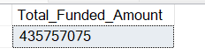
5) Month to Date (MTD) Funded Amount
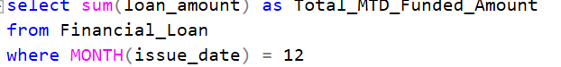
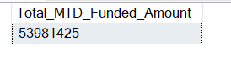
6) Previous Month to Date (PMTD) Funded Amount
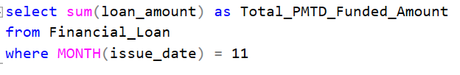
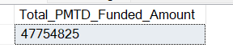
Received Amount
7) Total Received Amount
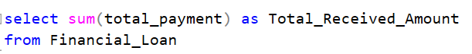
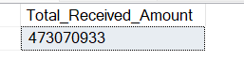
8) Month to Date (MTD) Received Amount
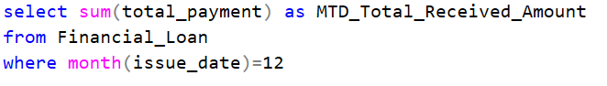
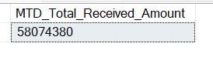
9) Previous Month to Date (PMTD) Received Amount
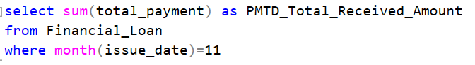
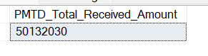
Average Interest Rate
10) Average Interest Rate
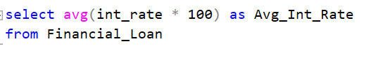
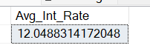
11) Month to Date (MTD) Average Interest Rate
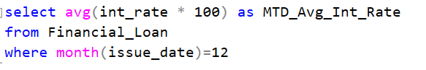
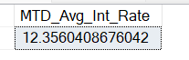
12) Previous Month to Date (PMTD) Average Interest Rate
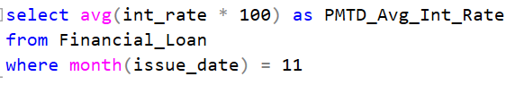
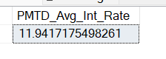
Average DTI
13) Average DTI
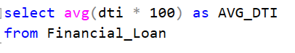
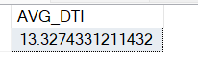
14) Month to Date (MTD) Average DTI
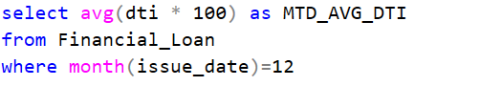
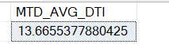
15) Previous Month to Date (PMTD) Average DTI
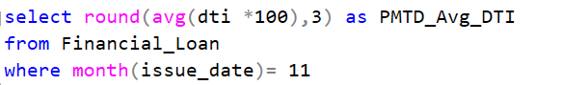
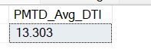

Good Loan Issued:
16) Good Loan Percentage
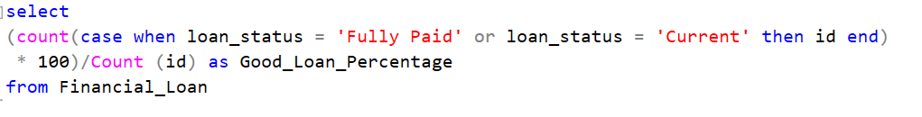
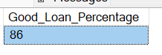
17) Good Loan Applications
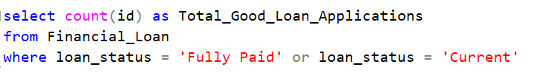
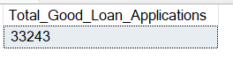
18) Good Loan Funded Amount
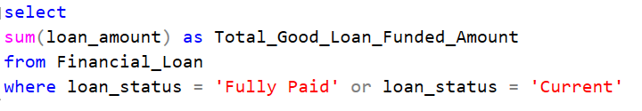
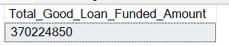
19) Good Loan Received Amount
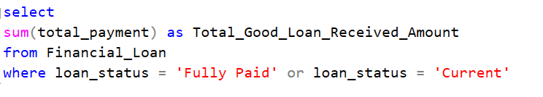
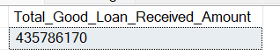
Bad Loan Issued:
16) Bad Loan Percentage
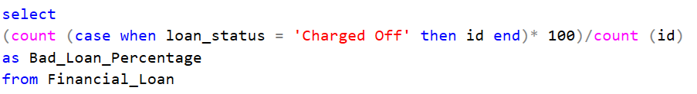
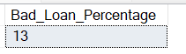
17) Bad Loan Applications
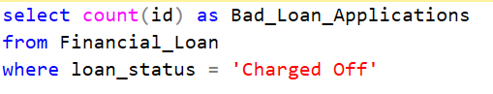
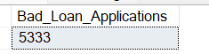
18) Bad Loan Funded Amount
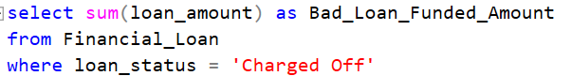
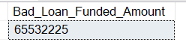
19) Bad Loan Received Amount
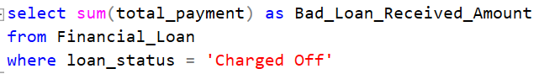
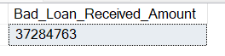
Loan Status:
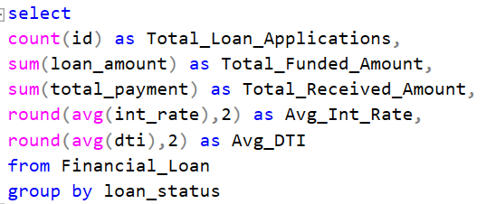
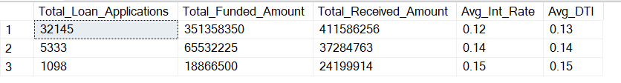
Bank Loan Report: Overview
Month:
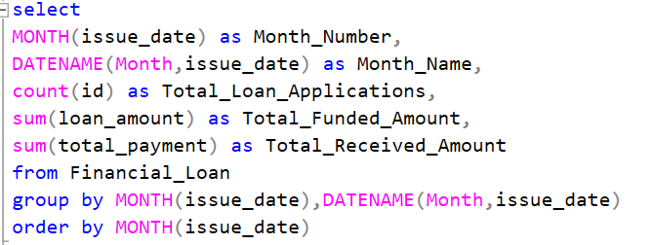
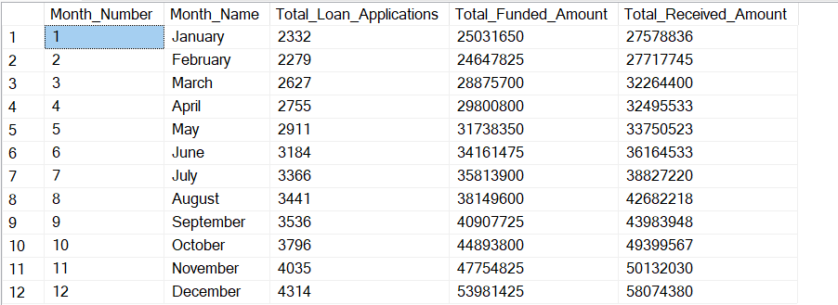
State:
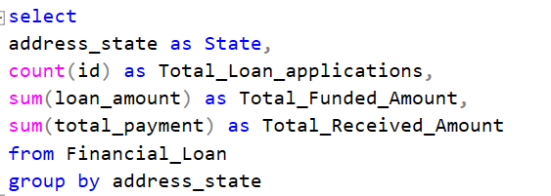
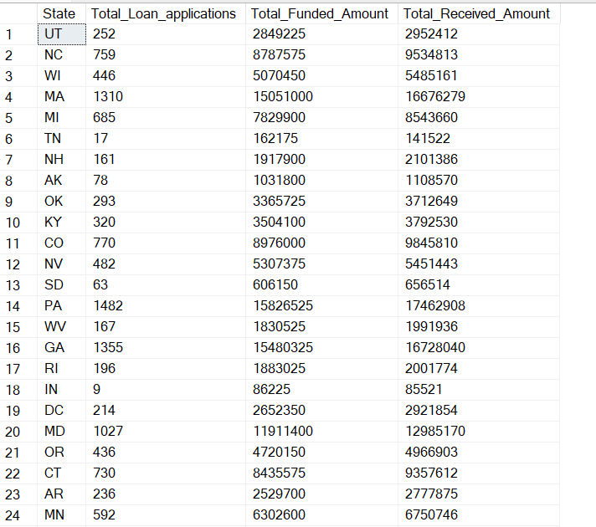
Term:
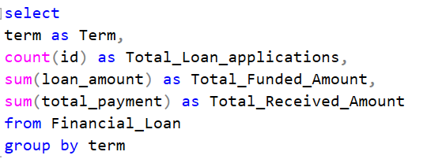
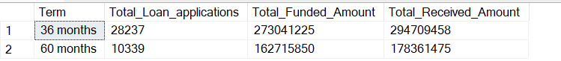
Employee Length:
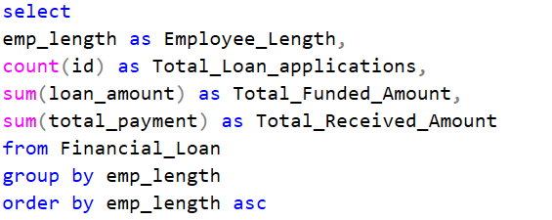
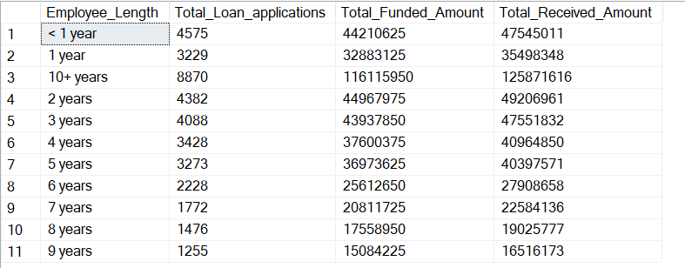
Purpose:
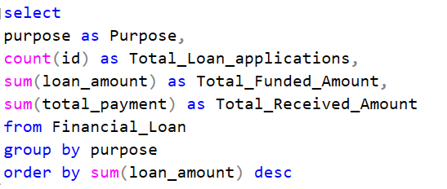
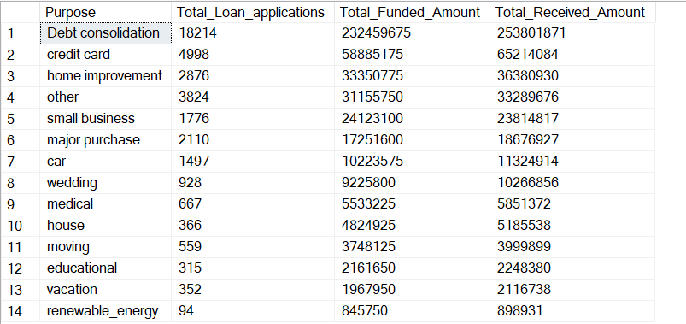
Home Ownership:
